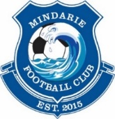
MINDARIE FC:
REFUND POLICY

Mindarie FC will provide a full refund of fees only if the below don’t apply:

- A $150 non-refundable deposit has been paid or early bird non-refundable deposit has been paid then this will be deducted from the full fees.
- Training kit has been provided i.e. the cost of the kit will be deducted from the full fees (this is included in the $150 non-refundable deposit)
- If Football West registration has been paid this will be deducted (on top of the $150) but will be transferred to any new club i.e. the FW rego fee will be deducted from the new clubs fees
- After first league game no refunds will be eligible.

Mindarie FC

